## Batch No:021

**EMPOWERING SUSTAINABLE AGRICULTURE THROUGH PROMOTION OF DROUGHT-RESISTANT CROPS AND CLIMATE RESILIENCE**

*Community Service Project report submitted*

*in partial fulfillment of the requirement for award of the degree of*

### Bachelor of Technology in

**Computer Science & Engineering By**

|  |  |  |
| --- | --- | --- |
| **PENTELA SRIKANTH**  **BANALA PAVAN KUMAR** | (23UECS0981)  (23UECS1021) | **(VTU26029)**  **(VTU26134)** |
| **LANKA ARUN** | (23UECS1117) | **(VTU26135)** |

*Under the guidance of Dr.N.RAJKUMAR,M.E.,Ph.D., PROFESSOR*

**

**DEPARTMENT OF COMPUTER SCIENCE & ENGINEERING SCHOOL OF COMPUTING**

### VEL TECH RANGARAJAN DR. SAGUNTHALA R&D INSTITUTE OF SCIENCE & TECHNOLOGY

**(Deemed to be University Estd u/s 3 of UGC Act, 1956) Accredited by NAAC with A++ Grade CHENNAI 600 062, TAMILNADU, INDIA**

**May 2025**

## Batch No:021

**EMPOWERING SUSTAINABLE AGRICULTURE THROUGH PROMOTION OF DROUGHT-RESISTANT CROPS AND CLIMATE RESILIENCE**

*Community Service Project report submitted*

*in partial fulfillment of the requirement for award of the degree of*

### Bachelor of Technology in

**Computer Science & Engineering By**

|  |  |  |
| --- | --- | --- |
| **PENTELA SRIKANTH**  **BANALA PAVAN KUMAR** | (23UECS0981)  (23UECS1021) | **(VTU26029)**  **(VTU26134)** |
| **LANKA ARUN** | (23UECS1117) | **(VTU26135)** |

*Under the guidance of Dr.N.RAJKUMAR,M.E.,Ph.D., PROFESSOR*

**

**DEPARTMENT OF COMPUTER SCIENCE & ENGINEERING SCHOOL OF COMPUTING**

### VEL TECH RANGARAJAN DR. SAGUNTHALA R&D INSTITUTE OF SCIENCE & TECHNOLOGY

**(Deemed to be University Estd u/s 3 of UGC Act, 1956) Accredited by NAAC with A++ Grade CHENNAI 600 062, TAMILNADU, INDIA**

**May 2025**

# CERTIFICATE

It is certified that the work contained in the project report titled ”EMPOWERING SUSTAINABLE AGRICULTURE THROUGH PROMOTION OF DROUGHT-RESISTANT CROPS AND CLIMATE RESILIENCE” by PENTELA SRIKANTH (23UECS0981), BANALA PAVAN KUMAR (23UECS

1021), LANKA ARUN (23UECS1117) has been carried out under my supervision and that this work has not been submitted elsewhere for a degree.

**Signature of Supervisor Dr.N.RAJKUMAR**

**Professor Computer Science & Engineering**

**School of Computing Vel Tech Rangarajan Dr. Sagunthala R&D Institute of Science and Technology**

**Signature of Head/Assistant Head of the Department Signature of the Dean**

**Dr. N. Vijayaraj/Dr. M. S. Murali dhar Dr. S P. Chokkalingam Professor & Head/ Professor &Assistant Head Professor & Dean Computer Science & Engineering School of Computing School of Computing Vel Tech Rangarajan Dr. Sagunthala R&D Vel Tech Rangarajan Dr. Sagunthala R&D Institute of Science and Technology Institute of Science and Technology**

# DECLARATION

We hereby declare that we have completed the mandatory community service project in the stipulated time period in Podili,prakasam under the guidance of our Project supervisor

(Signature) PENTELA SRIKANTH

Date: / /

(Signature) BANALA PAVAN KUMAR

Date: / /

(Signature) LANKA ARUN

Date: / /

# APPROVAL SHEET

This project report entitled ”EMPOWERING SUSTAINABLE AGRICULTURE THROUGH PRO- MOTION OF DROUGHT-RESISTANT CROPS AND CLIMATE RESILIENCE” by PENTELA SRIKANTH(23UECS0981), BANALA PAVAN KUMAR (23UECS1021), LANKA ARUN (23UEC-

S1117) is approved for the degree of B.Tech in Computer Science & Engineering.

### Examiners Supervisor

Dr.N.RAJKUMAR, M.E.,Ph.D.,

PROFESSOR

**Date: / / Place:**

## ACKNOWLEDGEMENT

We express our deepest gratitude to our **Honorable Founder Chancellor and President Col. Prof. Dr. R. RANGARAJAN B.E. (Electrical), B.E. (Mechanical), M.S (Automobile), D.Sc., and Foundress President Dr. R. SAGUNTHALA RANGARAJAN M.B.B.S.** Vel Tech Rangarajan Dr. Sagunthala R&D Institute of Science and Technology, for their blessings.

We express our sincere thanks to our respected Chairperson and Managing Trustee **Dr.Mrs.RANGARAJAN MAHALAKSHMI KISHORE,B.E., Vel Tech Rangarajan Dr. Sagunthala R&D Institute of Science and Technology, for her blessings.**

We are very much grateful to our beloved **Vice Chancellor Prof. Dr.RAJAT GUPTA,Ph.D.,** for providing us with an environment to complete our project successfully.

We record indebtedness to our **Professor & Dean, School of Computing, Dr.SP.CHOKKALINGAM, M.Tech., Ph.D., Professor & Associate Dean, School of Com- puting, Dr.V. DHILIP KUMAR, M.E.,Ph.D.,** for their immense care and encouragement towards us throughout the course of this project.

We are thankful to our **Professor & Head, Department of Computer Science & Engineering, Dr. N. VIJAYARAJ, M.E., Ph.D.,** and **Professor & Assistant Head, Dr. M. S. MURALI DHAR, M.E., Ph.D.,**for providing immense support in all our endeavors.

We also take this opportunity to express a deep sense of gratitude to our **Internal Supervisor Dr.N.RAJKUMAR, M.E.,Ph.D.,** for his cordial support, valuable information and guidance, he helped us in completing this project through various stages.

A special thanks to our **Over all Project Coordinator Dr.M.SADISH SENDIL,B.E.,M.E.,PhD. and Project Coordinators Mr.V.JAGANRAJA,B.Tech,M.E., Mr.V.ASHOK KUMAR, B.E,M.Tech.,** for their valuable guidance and support throughout the course of the project.

We thank our department faculty, supporting staff and friends for their help and guidance to com- plete this project.

**PENTELA SRIKANTH (23UECS0981) BANALA PAVAN KUMAR (23UECS1021) LANKA ARUN (23UECS1117)**

# LIST OF FIGURES

* 1. **Awareness of climate resilient crops** . . . . . . . . . . . . . . . . . . . . . . . . . 2
  2. **challenges in ESA** . . . . . . . . . . . . . . . . . . . . . . . . . . . . . . . . . . . 3
  3. **Survey location (podili)** . . . . . . . . . . . . . . . . . . . . . . . . . . . . . . . 4
  4. **Certificate from the office of Community** . . . . . . . . . . . . . . . . . . . . . . 5

#### Survey on Awareness of ESA 12

#### Responses on Drought-Resistant Crops 12

#### Occupational Distribution 13

#### Interaction With Farmers 14

#### Problem Identification 15

#### Development of solution 16

# LIST OF TABLES

Table 3.1 Activity Log-Day 1-5. 6

Table 3.2 Activity Log-Day 6-10. 7

Table 3.3 Activity Log-Day 11-15. 8

# LIST OF ACRONYMS AND ABBREVIATIONS

**CRA** Climate-Resilient Agriculture

**DRC** Drought-Resistant Crops

**ESA** Empowering Sustainable Agriculture

**FAO** Food and Agriculture Organization

**GAP** Good Agriculture Practices

**ICT4Ag** Information and Communication Technologies for Agriculture

**NRM** Natural Resource Management

**RD** Research and Development

**SDG** Sustainable Development Goals

# TABLE OF CONTENTS

|  |  |
| --- | --- |
| **LIST OF FIGURES LIST OF TABLES**  **LIST OF ACRONYMS AND ABBREVIATIONS**  **1 EXECUTIVE SUMMARY** | **v vi vii**  **1** |
| **2 OVERVIEW OF THE COMMUNITY** | **4** |
| 2.1 Certificate from the office of Community . . . . . . . . . . . . . . . . . . . . . . . . | 5 |
| **3 ACTIVITY LOG & OUTCOME** | **6** |
| 3.1 Project Activity Log . . . . . . . . . . . . . . . . . . . . . . . . . . . . . . . . . . . | 6 |
| 3.2 Project Outcome . . . . . . . . . . . . . . . . . . . . . . . . . . . . . . . . . . . . | 9 |
| **4 BACKGROUND SURVEY ANALYSIS FOR PROBLEM STATEMENT** | **10** |
| 4.1 Background Study . . . . . . . . . . . . . . . . . . . . . . . . . . . . . . . . . . . | 10 |
| 4.2 Survey Analysis with report . . . . . . . . . . . . . . . . . . . . . . . . . . . . . . | 12 |
| 4.3 Geotagged Photos and Details . . . . . . . . . . . . . . . . . . . . . . . . . . . . . | 14 |
| 4.4 Society Relevant Problem Identification . . . . . . . . . . . . . . . . . . . . . . . . | 15 |
| 4.5 Development of Problem solution . . . . . . . . . . . . . . . . . . . . . . . . . . . | 16 |
| **5 RECOMMENDATIONS AND CONCLUSION** | **20** |
| 5.1 Recommendations . . . . . . . . . . . . . . . . . . . . . . . . . . . . . . . . . . . | 20 |
| 5.2 Conclusion . . . . . . . . . . . . . . . . . . . . . . . . . . . . . . . . . . . . . . . . | 22 |
| **A REFERENCES** | **23** |

**Chapter 1**

# EXECUTIVE SUMMARY

In an era marked by escalating climate change and increasing water scarcity, global agriculture faces unprecedented challenges. Droughts, erratic weather patterns, and shifting growing seasons are not only threatening crop yields but also the livelihoods of millions of smallholder farmers around the world. In response to these urgent concerns, our initiative,” Empowering Sustainable Agricul- ture,” aims to harness the power of digital technology to promote climate-resilient farming practices through an interactive and informative website dedicated to drought-resistant crops and sustainable agricultural techniques.

**Goals and Objectives:**

The goal of this project is to promote sustainable and climate-resilient agriculture by developing a user-friendly website that serves as a comprehensive digital resource for drought-resistant crops and adaptive farming practices. The platform aims to educate and empower farmers, agricultural workers and rural communities by providing region-specific in- formation on drought-tolerant crop varieties, sustainable land and water management techniques, and climate-smart agricultural methods. It also seeks to raise awareness about the importance of resilient agriculture in the face of climate change, provide practical guidance through tutorials and expert content, and support informed decision-making with weather updates and planting tools. In addition, the website will promote knowledge exchange through community forums, highlight government schemes and subsidies related to sustainable agriculture, and build partnerships with institutions and NGOs to continue innovation and content sharing. By reaching a broad audience, the project ultimately aims to strengthen food security, conserve natural re- sources, and encourage long-term environmental stewardship.

#### Intended Impact :

#### The intended impact of this project is to enhance the resilience of agricultural communities to climate change by increasing the adoption of drought-resistant crops and sustainable farming practices. Through accessible digital resources, the platform will empower farmers to make informed decisions that lead to improved crop yields, reduced dependency on water-intensive methods, and greater food security. It aims to minimize the adverse effects of drought and erratic weather on agriculture, support rural livelihoods, and encourage environmental conservation. Additionally, the project will promote awareness, education, and innovation in climate-smart agriculture, contributing to long-term sustainability and the well-being of both people and the planet.

#### Beneficiaries :

#### The primary beneficiaries of this project are small and marginal farmers, especially those in drought prone and climate-vulnerable regions. Other key beneficiaries include agricultural ex- tension workers, rural communities, agribusiness professionals, researchers, students, NGOs, and policymakers involved in sustainable agriculture and climate resilience. By providing accessible knowledge and tools, the platform also benefits youth and aspiring agriculture entrepreneurs seeking modern, climate-smart farming solutions.

#### Social Issue :

#### The project addresses the pressing social issue of climate change and its impact on agriculture, particularly the increasing vulnerability of smallholder farmers to droughts, water scarcity, and declining crop productivity. Many farming communities lack access to reliable information, adaptive technologies, and support systems needed to cope with these challenges, leading to food insecurity, poverty, and rural distress. The lack of awareness about climate-resilient practices and drought-resistant crops further exacerbates their socio-economic struggles, making sustainable agriculture both a necessity and a pathway to resilience and improved livelihoods.

#### The Challenges :

Promoting sustainable agriculture through drought-resistant crops and climate resilience faces several significant challenges as shown in (Figure 1.2) that hinder widespread adoption and effectiveness. One of the primary obstacles is the limited access to drought-tolerant seeds, particularly for smallholder farmers who often lack the financial resources or market reach to obtain improved crop varieties. Insufficient awareness and education further exacerbate this issue, as many farmers are not informed about the benefits or cultivation practices of these resilient crops. In many rural areas, agricultural extension services are weak or nonexistent, limiting the dissemination of vital knowledge. Climate variability and extreme weather events—such as unpredictable rain- fall, heatwaves, and prolonged droughts—also pose a serious threat, sometimes overwhelming even the most resilient crop varieties. Infrastructural deficiencies, including poor irrigation systems, lack of storage facilities, and weak transportation networks, reduce the effectiveness and profitability of climate-resilient practices.

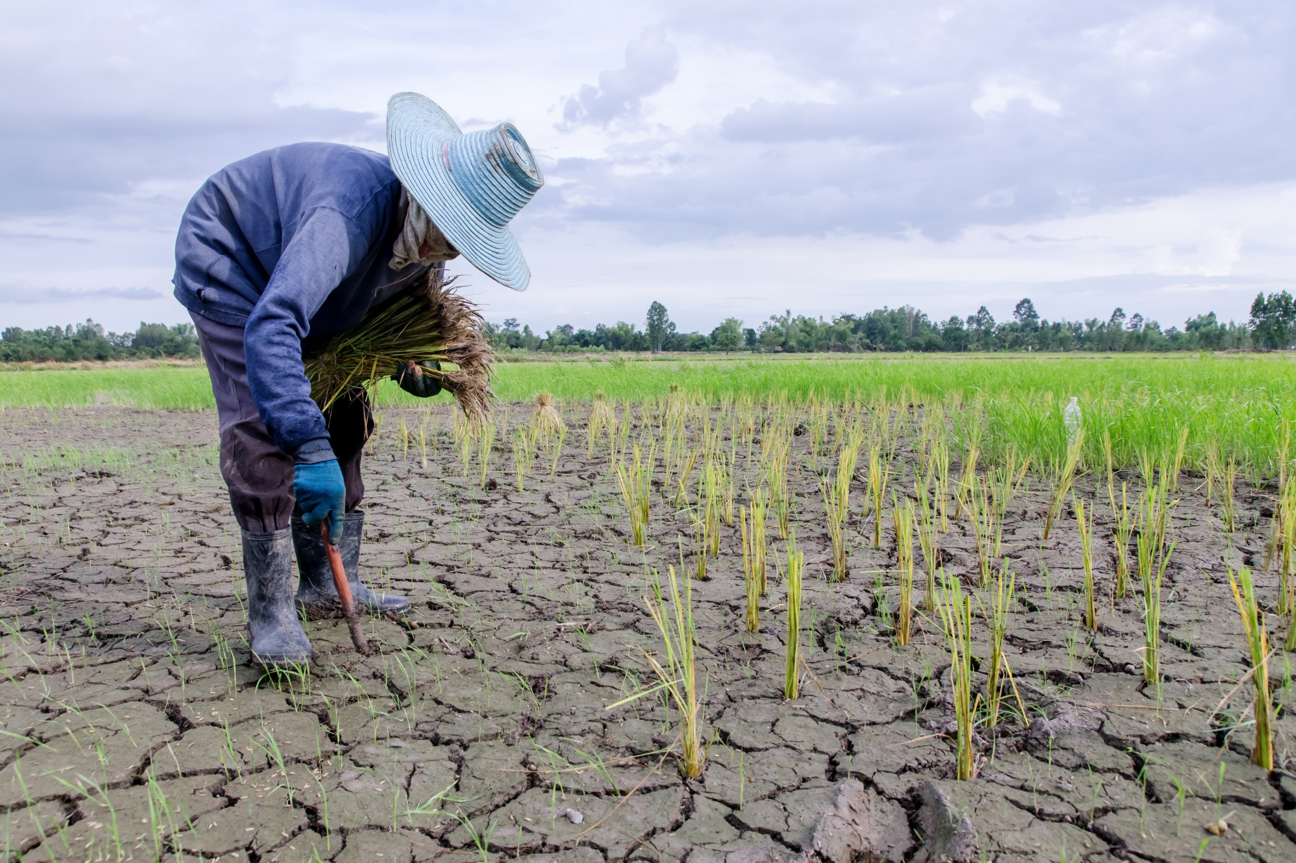

Figure 1.1: **Awareness of climate resilient crops**

#### The Awareness :

Awareness of sustainable agriculture, particularly the promotion of drought-resistant crops and climate resilience, has been growing steadily in recent years, driven by the increasing impacts of climate change on food systems as shown in (Figure 1.1) Governments, NGOs, research institutions, and international organizations have launched numerous initiatives to educate farmers and communities about the benefits of adopting drought-tolerant crops and climate-smart practices. Through farmer field schools, extension services, community workshops, and media campaigns, these efforts aim to enhance knowledge about how such crops can improve yields under water-scarce conditions, re- duce vulnerability to climate shocks, and promote long-term food security. Additionally, climate resilience is being emphasized in educational curriculums and rural development policies, helping to integrate

sustainable practices into local planning. However, awareness levels still vary significantly across regions, particularly in remote and marginalized communities where access to information and training remains limited.

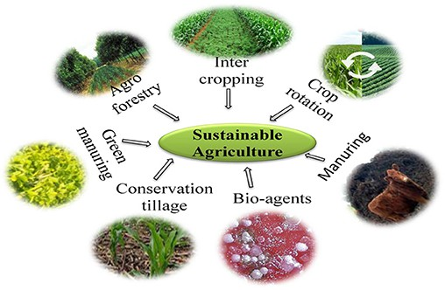

Figure 1.2: **challenges in ESA**

**Chapter 2**

# OVERVIEW OF THE COMMUNITY

#### Location:2.1 Introduction to the School

Podili, is a delightful village where unity thrives among its residents. The village is known for its vibrant festivals and rich cultural heritage, which are celebrated with great enthusiasm by everyone. Farming is an essential part of the villager’s lives, and they take pride in their sustainable farming practices, cultivating lush green fields that surround the area. In podili, you’ll experience a harmonious blend of community spirit, lively festivities, and a deep connection to the land through their farming traditions.

Despite various castes, religions, and backgrounds coexisting, there’s a palpable feeling of brotherhood. Conflicts are rare and are swiftly resolved through community dialogues, emphasizing mutual respect and understanding. podili is more than just a village; it’s a living model of community living, sustainable practices, and cultural preservation. A visit to this delightful village is not just a journey through its scenic landscapes but a deep dive into the heart of a community that thrives on unity, respect, and a shared love for their land and traditions.

#### The figure 2.1 represents the location of the podili city

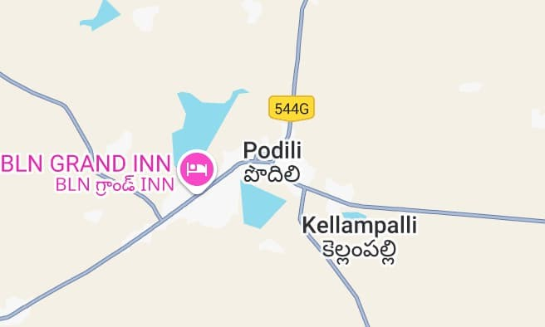

Figure 2.1: **Survey location (podili)**

### Certificate from the office of Community

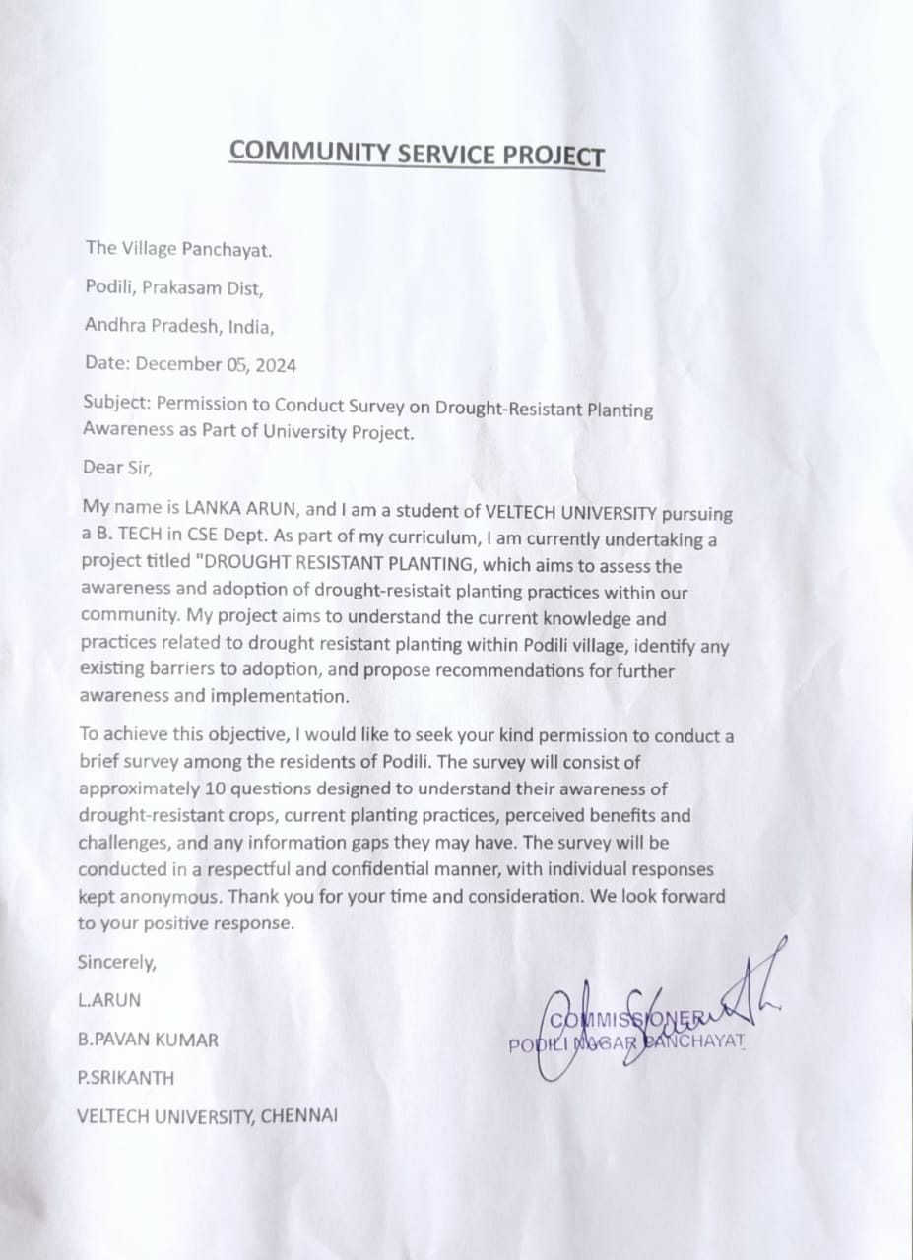

Figure 2.2: **Certificate from the office of Community**

**Chapter 3**

# ACTIVITY LOG & OUTCOME

### Project Activity Log

Table 3.1 **Activity Log-Day 1-5**

|  |  |  |
| --- | --- | --- |
| ACTIVITY LOG-DAY 1-5 | | |
| DATE | BRIEF DESCRIPTION OF THE DAILY ACTIVITY | LEARNING OUTCOME |
| 10.12.2024 | Team formation and project topic final- ization | Understood the importance of team col- laboration and project planning. |
| 15.12.2024 | Research on drought-resistant crops and climate resilience | Research on drought-resistant crops and climate resilience |
| 20.12.2024 | Studied the village Podili and its agricul- tural practices | Learned about local farming conditions and needs. |
| 15.01.2025 | Designed and prepared survey question- naires | Developed skills in creating effective re- search tools. |
| 21.01.2025 | Conducted field survey in Podili | Gained hands-on experience in data col- lection |

#### Summary of Activity Log (Day 1–5) :

In Days 1–5, as shown in (Table 3.1) the focus was on creating and refining a survey on CSA awareness, distributing it, and analyzing initial responses. This phase helped identify major knowledge gaps and common challenges faced by farmers regarding CSA.

Table 3.2 **Activity Log-Day 6-10**

|  |  |  |
| --- | --- | --- |
| ACTIVITY LOG-DAY 6-10 | | |
| DATE | BRIEF DESCRIPTION OF THE DAILY ACTIVITY | LEARNING OUTCOME |
| 26.01.2025 | Analyzed survey results and identified key problems | Developed analytical thinking and prob- lem identification skills |
| 02.02.2025 | Brainstormed and finalized a novel solu- tion | Practiced creative thinking and innova- tion |
| 12.02.2025 | Started prototype development of the awareness website | Applied web development skills in a real- world context |
| 19.02.2025 | Continued website development – fron- tend design | Improved UI/UX and HTML/CSS skills |
| 25.02.2025 | Implemented backend and database sup- port | Gained experience with full stack devel- opment |

#### Summary of Activity Log (Day 6-10) :

In Days 6-10, as shown in (Table 3.2) Conducted survey analysis to identify key issues, honing analytical and problem- identification skills. Through team brainstorming, developed a novel solution, applying creative thinking and innovation. Initiated and progressed on a prototype awareness website, enhancing both frontend (UI/UX, HTML/CSS) and backend (database, server-side logic) development skills, resulting in comprehensive full-stack development experience.

Table 3.3 **Activity Log-Day 11-15**

|  |  |  |
| --- | --- | --- |
| ACTIVITY LOG-DAY 11-15 | | |
| DATE | BRIEF DESCRIPTION OF THE DAILY ACTIVITY | LEARNING OUTCOME |
| 03.03.2025 | Integrated content on drought-resistant crops into the website | Enhanced understanding of agricultural content curation |
| 04.03.2025 | Tested and debugged the website | Strengthened testing and debugging capa- bilities. |
| 18.03.2025 | Collected geo-tagged photos and pre- pared media content | Learned to use geolocation tools and mul- timedia editing |
| 22.03.2025 | Final review and edits based on feedback from peers and mentor | Learned to incorporate feedback con- structively |
| 24.03.2025 | Presented the completed project and doc- umented outcomes | Gained experience in professional presen- tation and documentation |

#### Summary of Activity Log (Day 11-15) :

In Days 11-15, Integrated informative content on drought-resistant crops, deepening skills in agricultural research and content curation. Conducted thorough testing and debugging to ensure functionality. Gathered geo-tagged photos and developed multimedia content, gaining hands- on experience with geolocation tools and media editing. Finalized the website through peer and mentor feedback, as shown in (Table 3.3) and concluded the project with a professional presentation and outcome documentation, strengthening communication and documentation abilities.

### Project Outcome

The successful implementation of the project ”Empowering Sustainable Agriculture Through Promotion of Drought-Resistant Crops and Climate Resilience” will result in increased awareness and adoption of climate-resilient agricultural practices among farmers, particularly in drought- affected regions. Farmers will have easy access to accurate, region-specific information on drought- tolerant crops, sustainable farming techniques, and climate adaptation strategies, enabling them to make informed decisions that improve crop productivity and resource efficiency. The website will serve as a long-term educational and support platform, fostering knowledge exchange, collaboration, and innovation within the agricultural community. Ultimately, the project will contribute to enhanced food security, reduced vulnerability to climate change, improved livelihoods for rural populations, and the promotion of environmentally responsible farming across the target regions.

**Tracking Progress** :

To ensure the effectiveness and continuous improvement of the platform, tracking progress will be an essential part of the project. The website will include built-in tools to monitor user engagement, such as the number of registered users, page visits, and time spent on specific resources like crop guides or training modules. Feedback forms and surveys will be regularly used to collect user insights, satisfaction levels, and suggestions for improvement. Additionally, partnerships with agricultural extension officers and local organizations will help gather on-the-ground data about changes in farming practices, crop yield improvements, and the adoption rate of drought-resistant crops. By analyzing this data over time, the project team can assess the real-world impact of the platform, identify areas for enhancement, and make data- driven decisions to better serve the needs of the farming community.

**Communication** :

Effective communication will play a vital role in the success of the project, ensuring that valuable information reaches the intended beneficiaries clearly and efficiently. Regular updates, newsletters, SMS alerts, and social media integration will help spread awareness about new content, weather updates, success stories, and government schemes. Collaborations with local radio stations, community leaders, agricultural extension workers, and NGOs will further strengthen offline outreach and promote the website in remote areas. By combining digital and grassroots communication strategies, the project aims to build trust, encourage active participation, and ensure the widespread adoption of climate-resilient farming practices.

**Documentation** :

Documentation will be a key component of the project to ensure transparency, continuity, and knowledge preservation. All phases of the project—from planning and development to implementation and evaluation—will be thoroughly recorded in both digital and print formats. This includes technical documentation of the website’s structure and features, training manuals, user guides, feedback reports, and case studies of farmers who successfully adopt the promoted practices. Regular progress reports and data analysis will also be documented to track the platform’s impact over time. By maintaining a well-organized and accessible archive of materials, the project not only supports continuous learning and improvement but also provides a valuable reference for future initiatives in sustainable and climate-resilient agriculture.

**Chapter 4**

# BACKGROUND SURVEY ANALYSIS FOR PROBLEM STATEMENT

Climate change has become a major threat to global agriculture, particularly in regions that depend heavily on rainfall and traditional farming methods. In many rural areas, farmers continue to struggle with unpredictable weather patterns, frequent droughts, poor soil conditions, and lack of access to timely agricultural knowledge. As part of the background research for this project, surveys and field interactions were conducted across several drought-prone regions. The findings revealed that a majority of farmers were either unaware of drought-resistant crop varieties or lacked the resources and guidance to implement climate-resilient practices. Many expressed a need for localized, easy-to- understand information and tools that could help them make informed decisions about crop selection, water use, and soil health. These insights strongly indicate a critical gap between available climate- smart agricultural knowledge and the rural communities that need it most. Therefore, the creation of a dedicated website becomes not only relevant but essential to bridge this information divide and empower farmers with solutions tailored to their specific environmental and economic conditions.

### Background Study

Agriculture is one of the most vulnerable sectors to climate change, especially in regions where farming is predominantly rain-fed and dependent on traditional techniques. In recent decades, rising global temperatures, prolonged dry spells, and erratic rainfall patterns have had severe impacts on crop production, food security, and rural livelihoods. Drought, in particular, has emerged as a recurring threat, leading to failed harvests, soil degradation, and increased economic distress for small and marginal farmers. These challenges are compounded by a lack of access to updated agricultural information, modern technology, and climate-resilient practices.

Despite scientific advancements in the development of drought-resistant crop varieties and sus- tainable farming technologies, adoption rates remain low among rural farmers due to poor dissem- ination of knowledge and lack of digital literacy. Several studies and reports have highlighted the critical need to bridge this information gap through inclusive, easily accessible platforms that cater to the real-time needs of farming communities. A background study conducted through interviews, community discussions, and agricultural surveys revealed that farmers are eager to adopt improved practices but face barriers such as language, affordability, and limited exposure to modern farming methods.

#### ESA Survey Questionnaire

1. How familiar are you with drought-resistant crops?
   * Very familiar
   * Somewhat familiar
   * Not familiar
2. Do you believe climate change affects agriculture in your area?
   * Yes, significantly
   * Yes, but occasionally
   * No, not at all
3. How many times do you experience drought-related crop loss?
   * Every season
   * Occasionally
   * Rarely
   * Never
4. What challenges do you face in adopting sustainable farming practices?
   * Cost
   * Lack of information
   * Limited availability
   * Other
5. How important is adopting climate-resilient crops for sustainable farming?
   * Very important
   * Moderately important
   * Not important
6. What type of crops do you currently grow?
   * Cereals
   * Pulses
   * Fruits and vegetables
   * Other
7. How do you manage irrigation on your farm?
   * Rain-fed only
   * Drip irrigation
   * Sprinklers
   * Traditional methods
8. Have you experienced challenges due to unpredictable weather patterns?
   * Frequently
   * Occasionally
   * Rarely
   * Never
9. Do you currently use any sustainable farming practices?
   * Yes, many
   * A few
   * None
10. Are you using drought-resistant seeds or crops?
    * Yes
    * No
    * Planning to adopt them

### Survey Analysis with report

* + 1. The majority of participants (58.8 percent) are within the 20–30 years age group, indicated in blue. The second largest group (17.6 percent) falls into the 31–40 years range, shown in red. Respondents aged 41–50 years and those 51 years and above each represent (11.8 percent) of the total, marked in orange and green, respectively. The data highlights that the survey is predominantly influenced by younger individuals in the 20–30 age bracket, while the older age groups have a smaller yet equal representation.

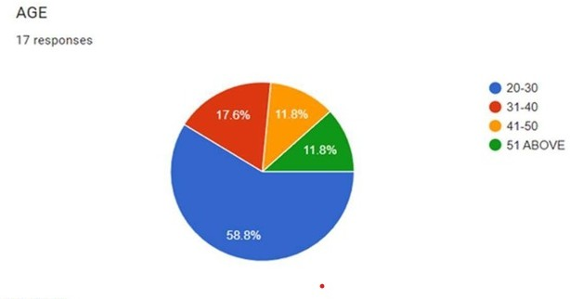

Figure 4.1: **Survey on Awareness of ESA**

* + 1. How many people are using drought-resistant crops?

The majority identified as male, comprising (70.6 percent) of the total responses. In contrast, females accounted for (29.4 percent) of the participants. This indicates that there were approximately 12 male respondents and 5 female respondents. Overall, the data shows a significant gender imbalance, with males being more than twice as many as females in this group.

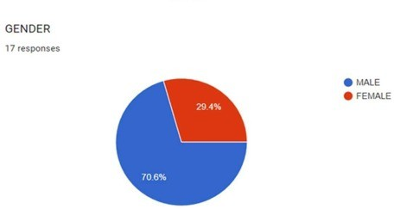

Figure 4.2: **Responses on Drought-Resistant Crops**

* + 1. The pie chart illustrates the occupational distribution of 16 respondents. It shows that (62.5 percent) of the individuals are farmers, represented by the blue section of the chart. Meanwhile, the remaining (37.5 percent) are engaged in other occupations, indicated by the red section. This data suggests that a majority of the respondents are involved in farming, highlighting agriculture as a significant occupation among the group surveyed.

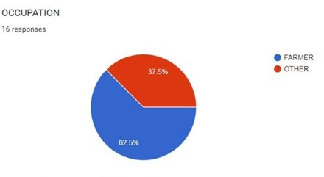

Figure 4.3: **Occupational Distribution**

### Geotagged Photos and Details

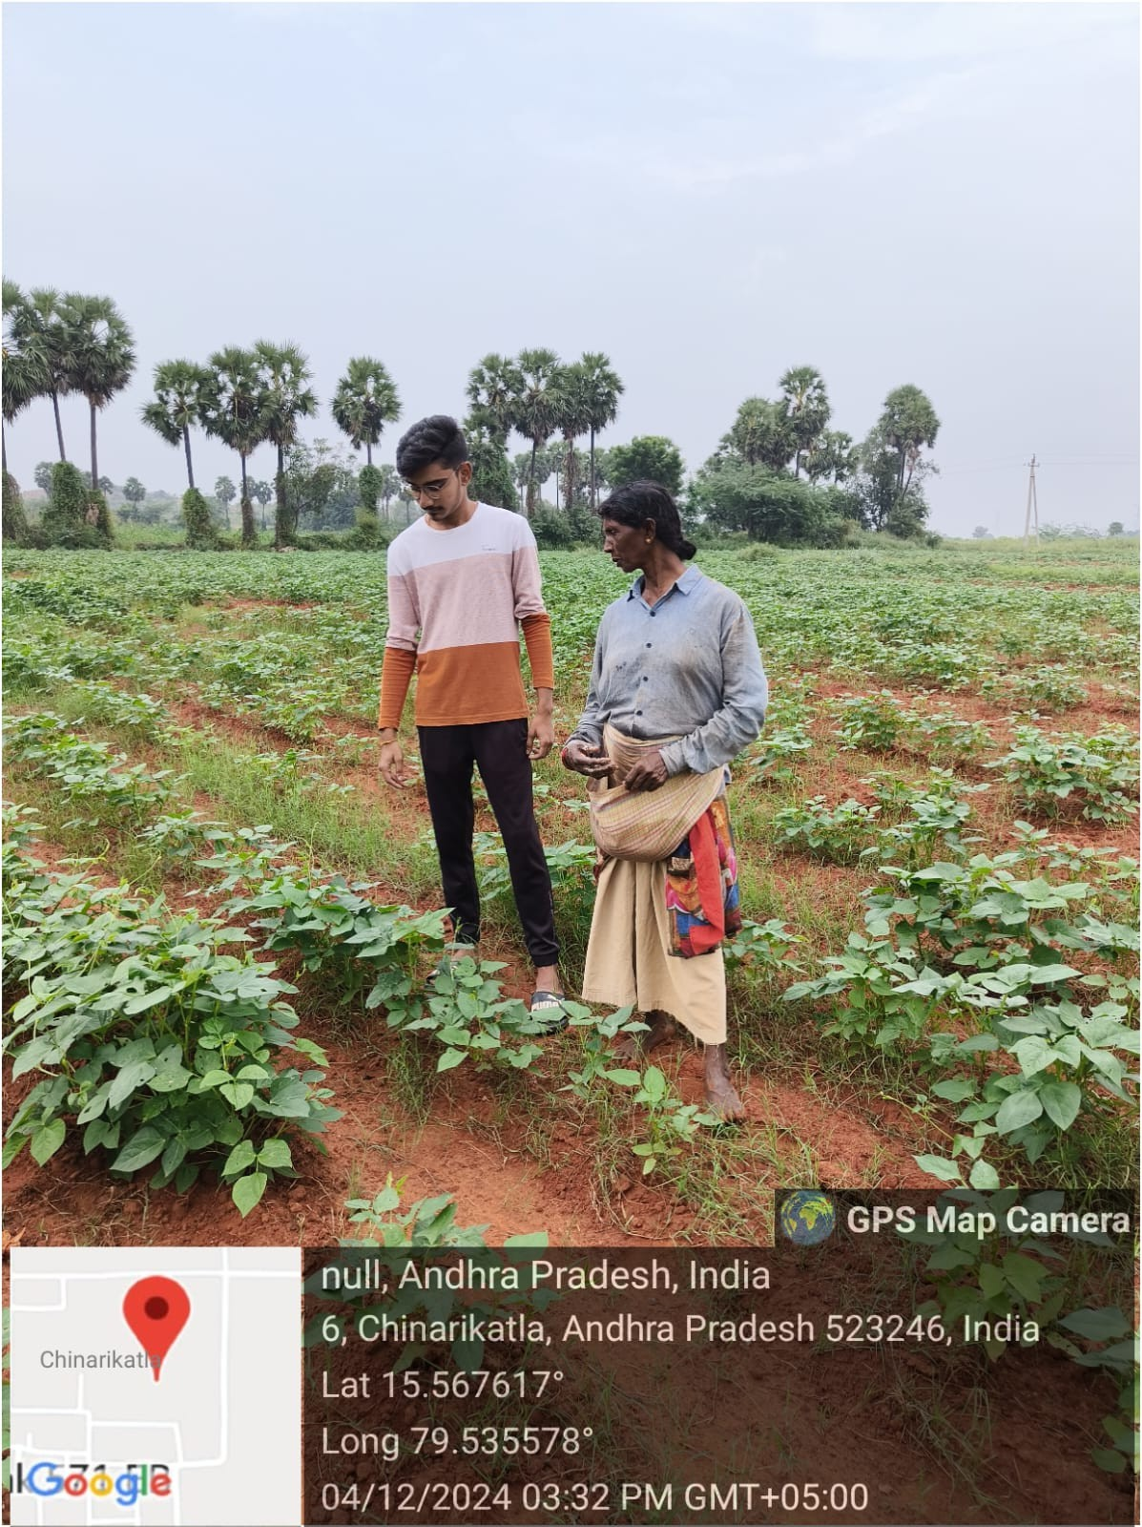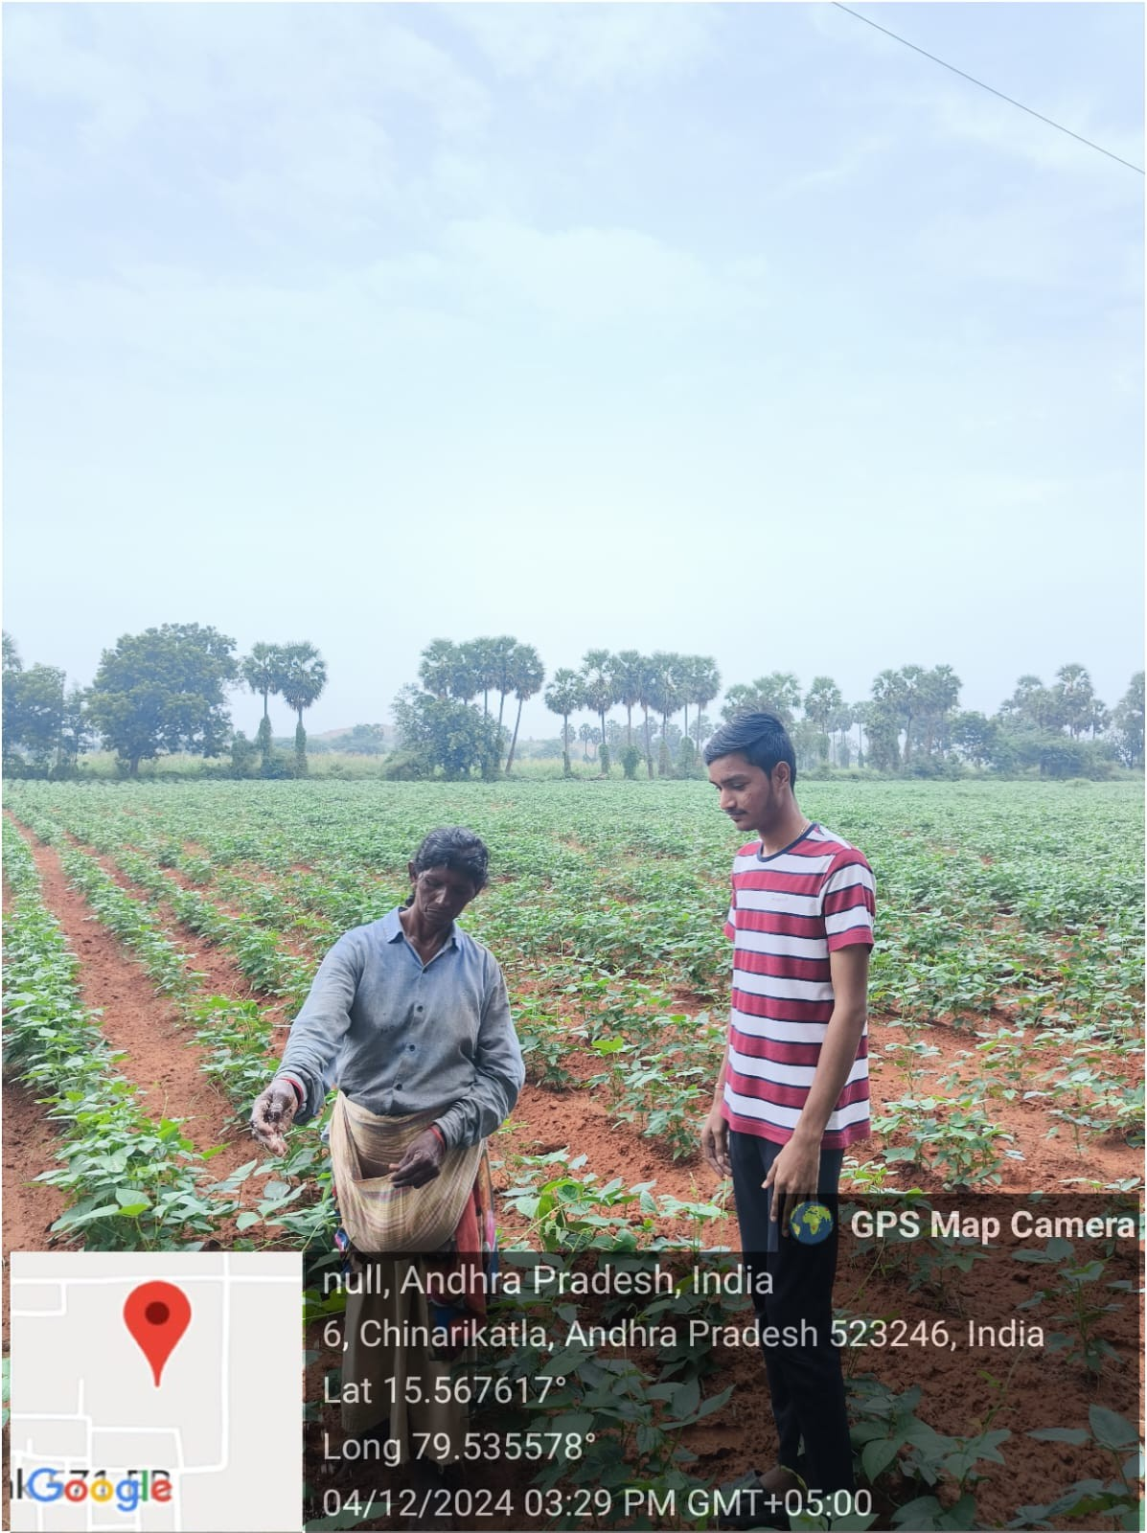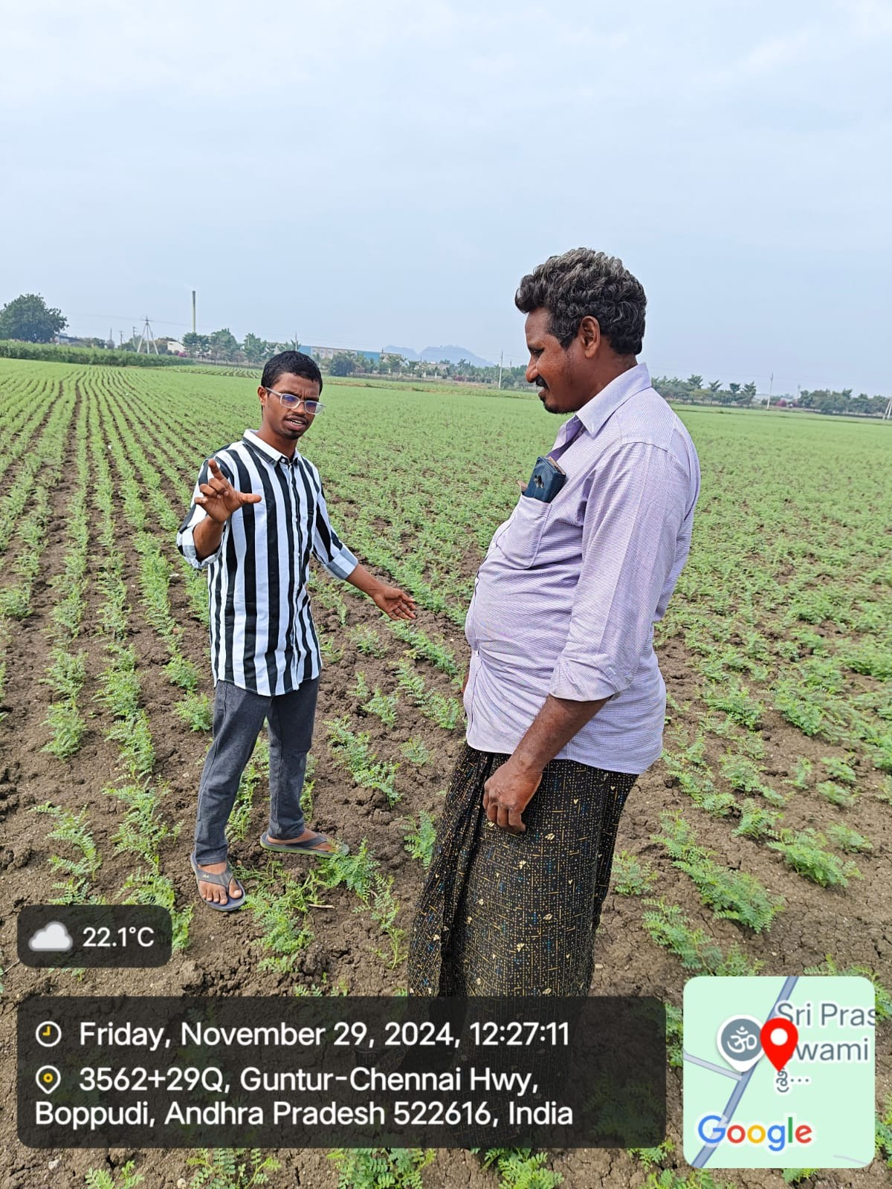

Figure 4.4: **Interaction With Farmers**

These are the Survey images capturing both students and farmers together on farming and serve as powerful visual representations of collaboration, learning, and the transfer of knowledge essential to promoting sustainable agriculture. These images highlight the active engagement of young learners in understanding real-world agricultural challenges and solutions, such as the adoption of drought- resistant crops and climate-resilient practices.

By documenting students participating in field surveys, soil testing, crop observation, or discussions with farmers, the images emphasize the bridge between academic knowledge and traditional farming wisdom. They also showcase how education and community involvement are critical to fostering innovation and encouraging the next generation to take part in sustainable farming. These visuals not only support awareness campaigns and research documentation but also inspire broader participation.

### Society Relevant Problem Identification

Climate change is increasingly threatening global food security, particularly in regions that are highly dependent on traditional agricultural practices and rain-fed farming systems. One of the most pressing challenges is the rising frequency and severity of droughts, which severely affect crop yields, degrade soil health, and undermine the livelihoods of millions of smallholder farmers. Despite the availability of drought-resistant crop varieties and climate-resilient farming techniques, there remains a significant gap in awareness, accessibility, and adoption of these solutions, especially in rural and underserved communities. Additionally, fragmented information, lack of localized data, and limited digital outreach hinder effective knowledge transfer and policy support. As a result, many farmers continue to rely on water-intensive crops that are increasingly unsustainable in changing climatic conditions. Addressing this issue requires a platform that not only educates but also connects farmers, researchers, policymakers, and agricultural stakeholders to promote the adoption of sustainable practices and resilient crops, ultimately strengthening food systems and rural economies in the face of climate adversity.

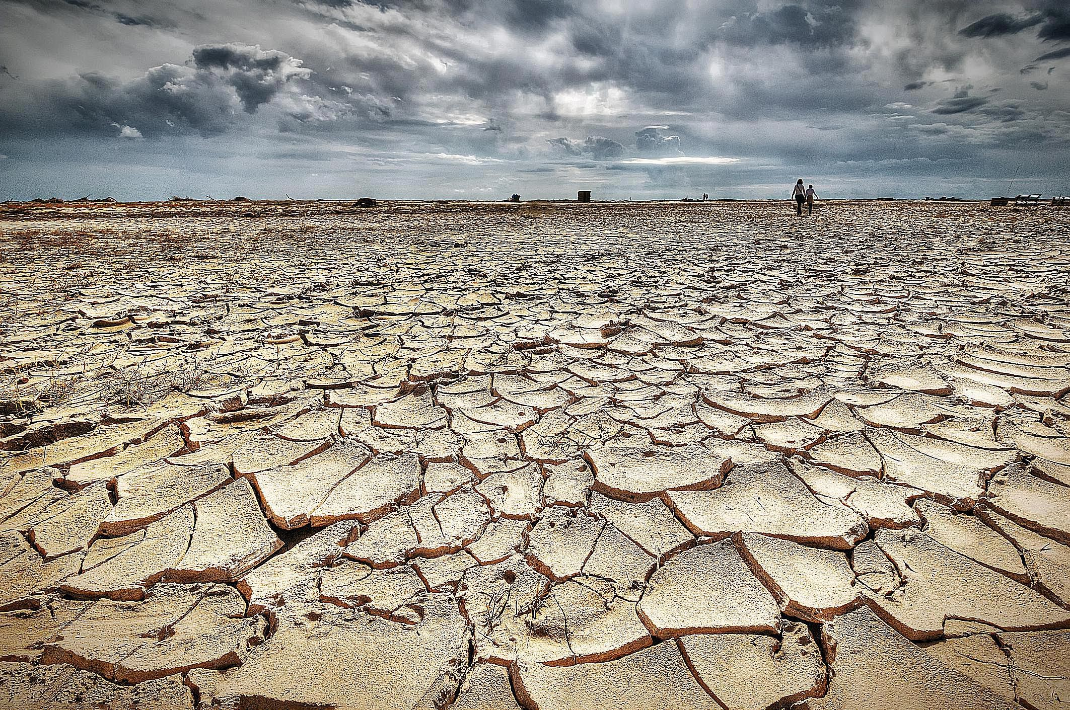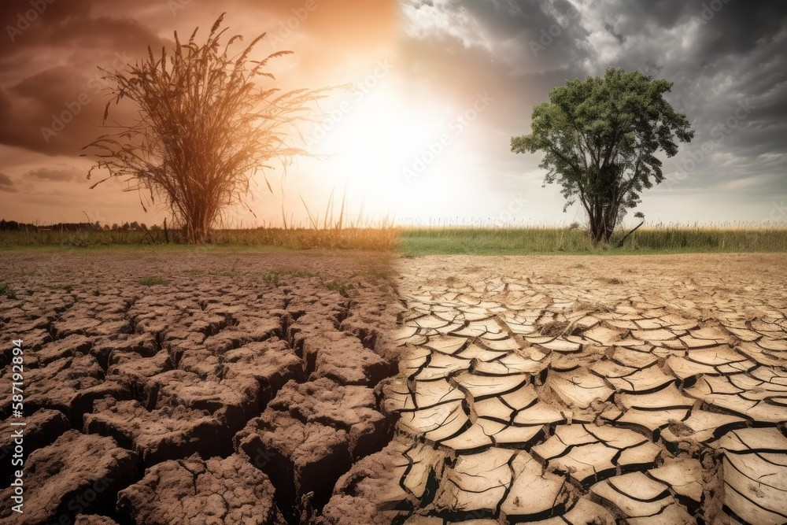

Figure 4.5: **Problem Identification**

### Development of Problem solution

To address the pressing challenges posed by climate change and drought to agriculture, the development of a dedicated website focused on promoting drought-resistant crops and climate resilience offers a practical and scalable solution. This platform would serve as an accessible digital hub where farmers, agricultural experts, and policymakers can interact and exchange vital information on sustainable farming practices. The website would provide scientifically backed content on drought- tolerant crop varieties, climate-smart techniques, soil and water conservation methods, and adaptive technologies tailored to different geographic regions. It would also feature real-time updates, localized weather forecasts, instructional videos, expert QA forums, and success stories to encourage peer learning and community engagement. By integrating multilingual support and mobile-friendly de- sign, the platform can reach underserved rural populations, bridging the information gap and empowering farmers to make informed decisions. In doing so, this initiative not only promotes environmental sustainability but also enhances food security and rural livelihoods by fostering a resilient agricultural ecosystem in the face of climate uncertainty.

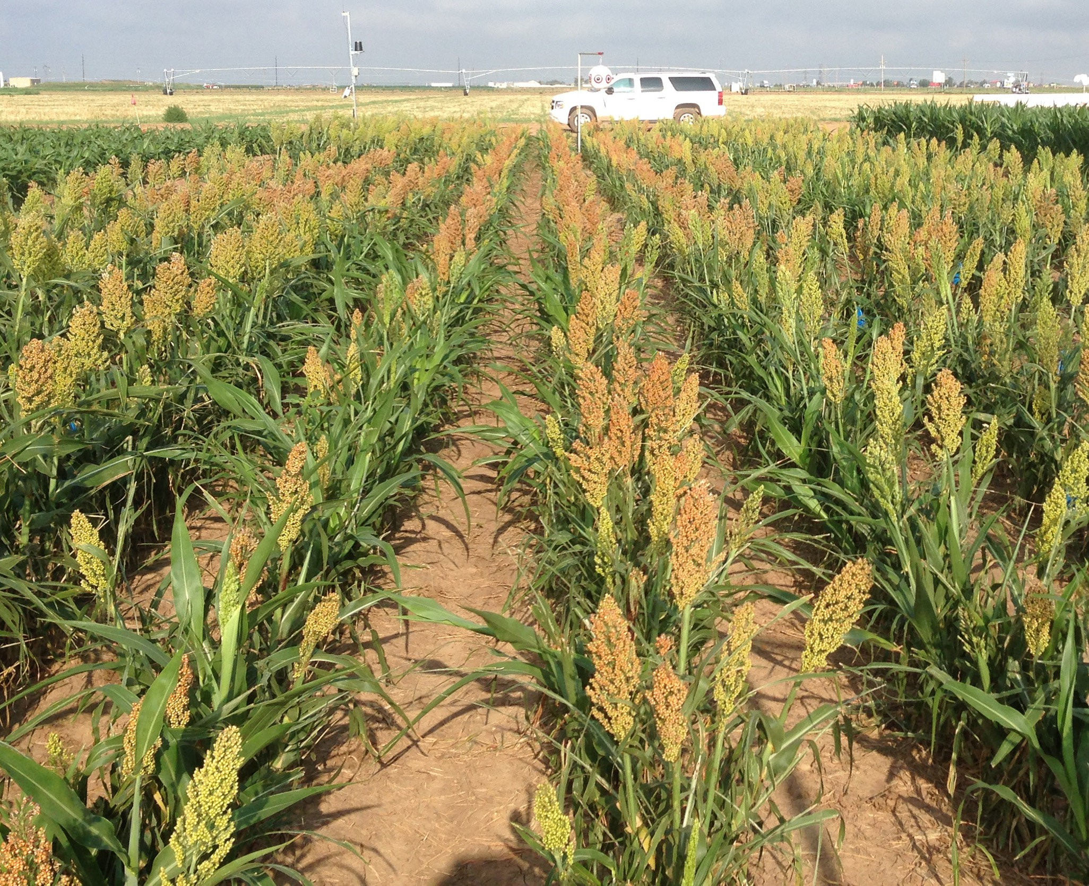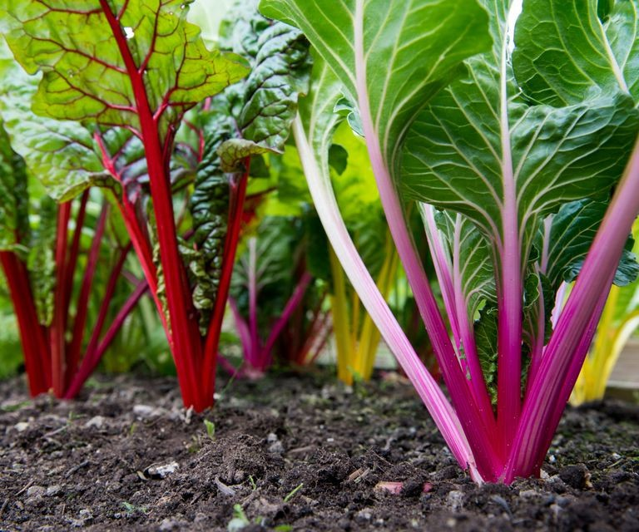

Figure 4.6: **Development of solution**

#### Cereal and Grain Crops 1.Sorghum

* Extremely drought-tolerant; grows well in arid conditions.

1. **Millets** (e.g., pearl millet, finger millet, foxtail millet)

* Fast-growing and resilient to heat and water scarcity.

#### Teff

* Hardy grain from Ethiopia that thrives in dry conditions.

#### Quinoa

* Tolerant to both drought and poor soils; performs well in changing climates.

#### Legumes and Pulses 1.Cowpea

* Heat- and drought-tolerant; fixes nitrogen and improves soil health.

#### Pigeon pea

* Deep-rooted, tolerates dry spells and poor soils.

#### Chickpea

* Requires low water and recovers well from mild drought.

#### Lentils

* Grows in semi-arid conditions and is moderately drought-tolerant.

#### Root and Tuber Crops 1.Cassava

* Can survive long droughts and still produce tubers.

#### 2.Sweet potato

* Tolerates poor soils and drought once established.

#### 3.Yam

* Some varieties show resilience to seasonal dry spells.

#### Vegetables and Other Crops 1.Amaranth

* Leafy green that thrives in dry, hot conditions.

#### 2.Moringa

* Extremely hardy tree crop; leaves and pods are nutritious.

#### 3.Okra

* Performs well under heat and low water availability.

#### Outline the issues you have recognized within the community

Within many agricultural communities, especially in drought-prone and rural regions, several critical issues hinder the transition toward sustainable and climate-resilient farming. One major challenge is the lack of awareness and knowledge about drought-resistant crop varieties and modern, climate- smart agricultural practices. Many farmers continue to rely on traditional methods and water-intensive crops, which are increasingly unsustainable in the face of prolonged droughts and erratic rainfall pat- terns. Additionally, there is limited access to timely, localized agricultural information, including weather forecasts, pest and disease warnings, and soil health recommendations. This lack of real- time data leaves farmers unprepared to respond to changing climate conditions effectively.

Another key issue is the digital divide. While urban areas may benefit from internet connectivity and access to advanced agricultural tools, many rural communities remain digitally excluded, lacking both the infrastructure and digital literacy needed to benefit from online resources. Furthermore, gov- ernment support and agricultural extension services are often insufficient or inconsistently delivered, leaving farmers without proper guidance or support systems. There is also a gap in the dissemina- tion of research findings from agricultural institutions to the grassroots level, creating a disconnect between innovation and practical application.

Compounding these problems is the economic vulnerability of smallholder farmers, who are often un- able to invest in resilient seeds, irrigation systems, or other technologies due to financial constraints. Without proper knowledge and support, they face high risks of crop failure, income loss, and food insecurity. These interconnected issues highlight the urgent need for a centralized, user-friendly, and inclusive platform that can serve as a bridge between scientific knowledge, policy, and practical farm- ing needs, empowering communities to adapt and thrive amidst growing climate challenges.

#### Short-term and long-term action strategy for addressing the identified issues. These solutions can be put forward to the relevant authorities for consideration and implementation.

**Short-Term Action Strategy** :

In the short term, the priority should be to establish a foundational digital platform that is simple, accessible, and targeted toward the immediate needs of farmers. This includes creating a user- friendly website with multilingual support, mobile compatibility, and offline access features to accommodate users in rural areas with limited internet connectivity. The platform should provide clear, concise information on drought-resistant crops, planting guidelines, water-saving techniques, and early warning systems for weather and pest outbreaks. Collaboration with local agricultural extension officers, NGOs, and community leaders will be crucial to ensure that the content is localized and relevant. Simultaneously, short-term awareness campaigns—through community radio, social media, and local gatherings—can promote the website and educate users about the benefits of climate-resilient practices. Training programs and digital literacy workshops should also be organized to help farmers, especially women and youth, navigate and utilize the platform effectively. These immediate actions will lay the groundwork for more sustainable and widespread adoption of climate-smart agriculture.

#### Long-Term Action Strategy :

#### For long-term sustainability and impact, the platform must evolve into a comprehensive digital ecosystem that facilitates ongoing innovation, collaboration, and support. This involves integrating advanced features such as personalized crop planning tools, AI-driven advisory services, climate data analytics, and marketplaces for drought-resistant seeds and eco-friendly inputs. Partnerships with agricultural research institutes, universities, and technology providers should be formalized to keep the platform updated with the latest scientific findings and best practices. Furthermore, policy advocacy should be a core component of the long-term strategy. Data collected from the platform can be analyzed to identify trends and inform policymakers about the needs and challenges of farming communities, ultimately shaping more effective agricultural and climate policies. To ensure inclusivity and resilience, long-term strategies must also focus on building community networks through farmer forums, mentorship programs, and cooperative groups facilitated by the platform. Capacity building initiatives should be institutionalized to empower youth and women in leadership roles within agricultural innovation. Investment in infrastructure—such as solar-powered internet kiosks or digital learning centers—will help bridge the digital divide and ensure that no community is left behind. With sustained commitment and multi-stakeholder engagement, this website can become a transformative tool for strengthening agricultural resilience and ensuring food security in the face of ongoing climate challenges.

**Chapter 5**

# RECOMMENDATIONS AND CONCLUSION

### Recommendations

**Make It a Handy Mobile App:**

A handy mobile app based on the website for promoting drought- resistant crops and climate resilience would make vital agricultural information easily accessible to farmers anytime, anywhere. With simple navigation, regional language support, offline access, and features like weather alerts, crop guides, and expert tips, the app can empower farmers to make informed decisions quickly. By putting climate-smart knowledge directly into their hands, the app would play a key role in supporting sustainable agriculture and building resilience against changing climate conditions.

**Support Local Languages and Voice Help:**

Many farmers are not comfortable using English or reading a lot of text. So, the app should support multiple local languages like Telugu, Hindi, or Tamil, based on the region. This will help farmers understand everything clearly in their own language. We can also add voice assistance, so farmers can just speak or listen instead of typing or reading. This makes the app much more user-friendly and inclusive for everyone, even for those who are not tech-savvy.

**Mobile App Development:**

Converting the website into a mobile application is a crucial step in ensuring that the platform reaches farmers effectively, especially in rural areas where smartphone usage is widespread but internet connectivity is often limited or unreliable. Mobile phones are one of the most accessible and commonly used technologies in these regions, making an app an ideal medium to deliver information and resources directly to farmers’ hands. By creating a mobile app, the platform can take advantage of the portability and convenience of smartphones, allowing farmers to access important content anytime, anywhere—whether they are in the field, on the go, or at home.

**Offline Access:**

Ensuring that the mobile app has offline capabilities is essential for making it ac- accessible to farmers in rural areas, where reliable and consistent internet connectivity is often a challenge. Many farmers in these regions may have limited or no access to stable internet, making it difficult to use online platforms that require constant data usage. By incorporating offline features into the app, farmers can still access critical information whenever they need it, regardless of internet availability.

**Step-by-Step Guides and Educational Resources:**

Including easy-to-follow guides, videos, and instructional content on drought-resistant crops and climate-resilient farming techniques is vital for ensuring that farmers have practical, understandable resources to implement sustainable agricultural practices. For many farmers, especially in rural areas, access to formal education or advanced agricultural training can be limited. Therefore, the content provided on the app needs to be simple, actionable, and directly relevant to their daily farming activities.

**Community Engagement:**

Enabling community forums within the mobile app is a powerful way to foster collaboration, knowledge-sharing, and peer-to-peer learning among farmers. These forums can serve as interactive spaces where farmers from different regions, backgrounds, and experiences can connect, ask questions, share insights, and learn from each other. This approach is particularly effective in rural communities, where access to formal agricultural extension ser- vices may be limited or sporadic.

**Peer-to-Peer Knowledge Exchange:**

Community forums allow farmers to exchange first-hand experiences, challenges, and solutions related to drought-resistant crops and climate-resilient farming practices. For example, a farmer in one region may share their success with a specific drought- resistant crop variety or a unique irrigation technique that has worked well in their area. An- other farmer from a neighboring region might offer advice on combating pests that thrive under changing climate conditions. By exchanging practical, real-world knowledge, farmers can build a sense of shared community and gain confidence in adopting new practices.

**Training and Digital Literacy Programs:**

Offering training sessions to improve digital literacy is a crucial strategy for ensuring the successful adoption of the platform, especially in rural com- munities where access to technology and digital skills may be limited. While smartphones and mobile apps are increasingly available in rural areas, many farmers may not be fully comfortable or familiar with using them for agricultural purposes. By providing targeted training, farmers can gain the skills and confidence needed to navigate the platform, access valuable information, and integrate digital tools into their farming practices.

### Conclusion

In conclusion, the initiative to create a website and mobile application for promoting drought- resistant crops and climate-resilient farming practices represents a significant step toward empower- ing farmers to adapt to the challenges of a changing climate. As climate change continues to impact agricultural productivity, particularly in vulnerable regions, it is essential to provide farmers with the tools, resources, and knowledge they need to build resilience and ensure food security. This platform, with its combination of accessible, user-friendly guides, region-specific content, offline capabilities, and community-driven knowledge sharing, has the potential to transform the way farmers approach climate-smart agriculture.

By focusing on the practical needs of farmers—whether it’s helping them identify the best drought- resistant crops, offering timely weather alerts, or providing step-by-step instructions for sustainable farming techniques—the platform empowers users to make informed, data-driven decisions. Further- more, integrating real-time pest and disease alerts, fostering peer-to-peer learning through community forums, and offering digital literacy training ensures that all farmers, regardless of their technological experience, can fully benefit from the platform.

The shift from traditional farming methods to more sustainable, climate-resilient practices is a long- term journey that requires ongoing support, education, and innovation. This platform provides a robust foundation for that transformation by combining the power of technology with localized, practical knowledge. As it expands, the app and website can help bridge the gap between farmers and the resources they need to thrive in the face of climate uncertainty.

Ultimately, the success of this initiative relies on continuous collaboration between governments, agricultural experts, local communities, and the private sector. With this collective effort, the platform can play a key role in improving agricultural practices, promoting environmental sustainability, and fostering economic resilience among farmers, ultimately contributing to a more secure and climate-resilient food system for future generations.

Building on the foundational work laid out by the platform, its long-term success will depend on its ability to adapt and evolve in response to emerging challenges in agriculture. As climate change continues to affect global weather patterns and agriculture, the demand for innovative solutions like drought-resistant crops and climate-resilient farming practices will grow. This platform offers a dy- namic and scalable solution that not only addresses immediate farming needs but also prepares farm- ers for future challenges, creating a foundation for sustainable agricultural practices for years to come. The comprehensive approach taken by the platform—focusing on the combination of practical tools, community engagement, and education—ensures that farmers are not just passive recipients of in- formation but active participants in the transformation of agriculture.

By providing educational re- sources, such as easy-to-follow guides, videos, and region-specific content, the platform empowers farmers to learn and grow alongside the technology, ensuring that they are well-equipped to implement the climate-smart practices that are essential for long-term sustainability.

In conclusion, our community service project has yielded valuable insights and outcomes that high- light the power of collective action in creating positive change. Through our efforts, we have wit- nessed the transformative effects of offering support, education, and resources to underserved mem- bers of our community.

**Appendix A**

# REFERENCES

* + 1. Srivastava, P. K. Gupta, and M. Kumar, ”Smart Agriculture Monitoring System Using Machine Learning,” IEEE International Conference on Computing, Communication and Automation (ICCCA), 2021.
    2. S. Patel, R. Sharma, and N. Yadav, ”Machine Learning Model for Predicting Crop Yield Using Soil Parameters,” International Journal of Advanced Science and Technology, Vol. 29, No. 6,

pp. 1529- 1540, 2022.

* + 1. K. S. Rao, T. Venkatesh, and A. Kumar, ”AI-Based Crop Disease Detection Using Image Processing,” Journal of Agricultural Informatics, Vol. 11, No. 3, pp. 45-55, 2021.
    2. P. Mishra, R. Jain, and M. Shah, ”Cloud-Based Platform for Farm Monitoring and Automation,” International Conference on Smart Technologies for Smart Nation, 2020.
    3. D. S. Reddy, A. K. Verma, and P. Mishra, ”Data-Driven Precision Agriculture Using Sensor Technology,” IEEE Sensors Journal, Vol. 20, No. 14, pp. 7800-7810, 2023.
    4. K. Singh, M. Gupta, and A. Kumar, ”Automated Irrigatio System Using Wireless Sensor Networks,” International Journal of Computer Applications, Vol. 182, No. 25, pp. 23-27, 2022.
    5. R. Sharma, N. K. Jain, and S. Gupta, ”Machine Learning Model for Soil Nutrient Prediction and Crop Recommendation,” International Journal of Advanced Research in Computer Science, Vol. 10, No. 6,pp. 456-462, 2021.
    6. N. Kumar, S. R. Reddy, and P. Mishra, ”An Integrated Framework for Crop Yield Prediction Using Machine Learning,” International Journal of Modern Agriculture, Vol. 11, No. 1, pp. 89-95, 2021.
    7. H. Wang, L. Zhang, and C. Li, ”Big Data Analytics in Smart Agriculture: A Review,” IEEE Access, Vol. 8, pp. 123456-123469, 2023.
    8. V. Patel, K. Sharma, and R. Mehta, ”Real-Time Crop Monitoring Using Cloud-Based Platform,” International Conference on Smart Farming, 2020.

#### General Instructions

* + - * **Wherever Figures applicable in Report , that page should be printed in color**
      * Don’t include general content , write more technical content
      * Each chapter should minimum contain 3 pages
      * Draw the notation of diagrams properly
      * Every paragraph should be started with one tab space
      * Literature review should be properly cited and described with content related to project
      * All the diagrams should be properly described and don’t include general information of any diagram
      * All diagrams, figures should be numbered according to the chapter number
      * All the references should be cited in the report
      * **Strictly don’t change font style or font size of the template, and don’t customize the latex code of report**
      * **Report should be prepared according to the template only**
      * **Any deviations from the report template, will be summarily rejected**
      * **Number of Project Soft Binded copy for each and every batch is (n+1) copies as given in the table below**